***ELANGOVAN RAJAH***

Email : [elanrajah@gmail.com](mailto:elanrajah@gmail.com)

Contact Details : +60166550459, +97455645280

Skype ID : elan_orchids

Contact Details : +60166550459, +97455645280

Skype ID : elan_orchids

**OBJECTIVE :**

A result oriented professional with qualitative experience of **over 16 years** in managing Quality Management Systems entailing Supplier Quality, Process Improvement, Auditing and Team Management in Logistics, Hotels, Manufacturing and Banking industry. Presently associated with **Gulf Warehousing Company, Doha, Qatar as Senior Quality Manager.**

Hands-on experience in design, implementation and accreditation of ISO standards, ISO 9001 (Quality Management System), ISO 14001 (Environmental Management System), OHSAS 18001 (Safety Management System), ISO 22000 (Food Safety Management System) and ISO 27001 (Information Technology Management System). Proficiency in developing as well as implementing new standards to meet organisational requirements in line with prevalent industry standards.

Proficient in streamlining processes / procedures to facilitate robust Quality Management Systems, adept in developing a framework of quality standards, procedures, systems, control and audit; provided quality training and setting standards in supplier quality related issues. Good analytical, troubleshooting and interpersonal skills with proven ability in driving numerous quality enhancement, process improvement and cost saving initiatives during the career span.

**AREA OF EXPERTISE :** **CAREER SYNOPSIS:**

* ISO Lead Auditor for 9001, 22000 and 27001
* Management Representative for ISO 9001, ISO 14001, OHSAS 18001, FSMS TL for ISO 22000 and ISMS Manager for ISO 27001
* Quality, HSE, FSMS/ HACCP, and ISMS Implementation and monitoring.
* Quality Assurance / Controls / Six Sigma
* Process Improvement and Business Process Re-engineering
* Internal Audit and Vendor Audit / Supplier
* Security Management
* Persuasive Communicator and Team Player
* Decision Making and Leadership
* In-house Trainer and Staff Development
* Supply Chain Management
* Experienced in Quality Management Systems and Security with over 16 years with local and overseas companies.
* Experienced with the Supply Chain Industry with over 12 years in Multi

Disciplinary, International / Cross-Cultural / Multi-Site Logistics Management Experience/ Cross Functional and Global Environment.

* Develop and implement integrated QEHS and managing a security team at Gulf Warehousing Company, Doha, Qatar
* Responsible for policy formation, implementation, audit, CAPA on all certified standard (QEHS Management, HACCP and Information Security)
* Hands on experience in auditing for integrated Quality Management System, Food Safety and information Security and supplier assurance.
* Conducting internal audits periodically to assess the status of deployment of systems and take corrective measures for achieving organizational objectives
* Reviewing and auditing vendor quality status, plan actions to attain continual quality improvement of vendors
* Executing cost saving techniques/ measures and modifications to achieve reduction in expenditures.
* Extensive experience in Manufacturing, Hotels and Banking industry.

**NOTABLE ACHIEVEMENT ACROSS TENURE :**

* Dexterously implemented:
* Successfully implemented a centeralised digital back up storage system for all company critical documents in 2013.
* ISO 27001: 2005 (ISMS) Certification for Gulf Warehousing Company, Doha, Qatar. Scope of Certification was for Data Center and accreditation from LRQA in August 2012.
* ISO 9001: 2008 Certification for Gulf Warehousing Company, Doha, Qatar, accreditation by LRQA in April 2011. Certification for 7 different sites in Doha and Middle East
* ISO 14001: 2004 Certification for Gulf Warehousing Company, Doha, Qatar, accreditation by LRQA in December 2009. Certification for 6 different sites in Doha.
* Process and procedure for Hazmat (Hazardous Material) Warehouse in Ras Laffan, Doha Qatar in October 2009.
* OHSAS 18001: 2007 Certification for Gulf Warehousing Company, Doha, Qatar, accreditation by LRQA in August 2009. Certification for 6 different sites in Doha.
* ISO 22000: 2005 (HACCP) Certification for Gulf Warehousing Company, Doha, Qatar, Accreditation from TUV Middle East in July 2007. Certification for 2 different sites in Doha.
* Holds the distinction of being recognised and bagged:
* Supply Chain & Transport Award for “Best Logistics Infrastructure in Middle East” held in Dubai, May 2012.
* Arabian Business Achievement Award, Qatar for “Best Logistics Company in Qatar for 3 consecutive years 2010 2011 and 2012.
* Supply Chain & Transport Award (SCATA 2011) for “Best 3PL Service Provider of the Year” from ITP held in Dubai, May 2011.

**OCCUPATIONAL CONTOUR:**

**Since Dec’06: Gulf Warehousing Company, Doha, Qatar as Senior Quality Manager. Industry : 3rd Party Logistics**

**Growth Path:**

**Dec’06 – Dec’11: Quality Manager**

**Jan 12 – Present: Senior Quality Manager**

**Notable Attainments:**

* Spearheaded a team of 116 staff members with 12 direct reports for Quality, HSE, and Security.
* Responsible for Quality, Safety and Health, Environment, Security for GWC both locally and regional.
* Served as a Management Representative for ISO: 9001, ISO: 14001, OHSAS: 18001, ISO: 22000 and ISO: 27001.
* Business Support Division administered 8 difference multi location in Qatar and Regional Facilities in Dubai, Jeddah, Riyadh, Dammam, and Nigeria.
* Analysing the risk management of the company and manage the disaster recovery plan for GWC
* Implemented a central documentation system to store and back up all important data of the company, such as tenders won, key contract, licenses and etc.
* Oversee 4,000 sqm Hazmat (Hazardous Material) Warehouse with development and enforcement of procedures, maintenance of equipment and safety of the warehouse. Ensured that all chemical products in the warehouse conform to international standard (CFR 49) of storage and transportation.
* Worked in close coordination with all Oil and Gas companies in Qatar to constantly develop procedures, process and safety to meet their requirements.
* Worked closely with Fast Food chain companies to ensure the food safety of their products is upheld during strange and delivery.
* Creating ISO / Quality / Safety awareness for the associates by internal trainings
* Managing all Management Reviews
* Review Safety Exercises /Accident data in all regions
* In-charge for Hazmat Spillage Team and Emergency Response Team for all sites
* Maintain “operational control” over operations and activities per GWC’s QEHS Manual.
* Conducts regular scheduled and unscheduled inspections and audits of facility sanitation, quality, safety, and environmental health for compliance with applicable guidelines
* Dexterously maintained and improved all certified standards ISO: 9001, ISO: 14001, OHSAS: 18001, ISO: 22000: Food Management System (HACCP) and ISO 27001: 2005 (Information Security System).
* Defining customer needs or problems areas and determines scope of investigation
* Conducting customer satisfactions survey and monitoring of customer complaints
* Periodically conducting internal and vendor audits on the system for ensuring compliance
* Developing effective solution and improvement of workflows, processes, user interfaces and system integration.
* Instrumental in conducting training courses for the following:
* Training and implementing QCC (Quality Control Circles) for process improvements and culture.
* Training and implementing a Total Quality Management culture
* Conducted ISO Awareness / Quality Controller / Food Safety and Information Security
* Providing training on process mapping and brainstorming
* Providing training on Risk Management and Disaster Recovery.
* Responsible for all customer audits and responsible to ensure that we comply with customers’ standard and regulatory requirements
* Pivotal in providing support and improvements to process for ensuring efficiency and driving continuous improvement through employee involvement and focused leadership.

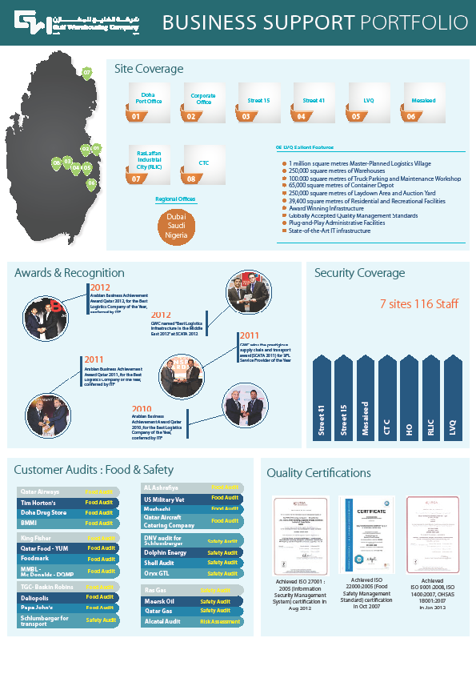

**Jul’02 – Nov’06: Lityan Holdings Berhad – Saujana Subang, Selangor, Malaysia as Quality Control Manager. Industry : Distribution of IT Equipment and Call Center**

**Notable Attainments:**

* Administered a team of 6 staff members
* Operations of the Call Centre Engineering Department, Logistics Department to ensure customer requirements were met.
* Successfully managed the Project for National Oil Company (Petronas Malaysia) for the logistics and distribution of computer hardware to all offices across Malaysia
* Ensured all the activities & proper platforms were established in order to successfully attain/maintain the ISO accreditation.
* Providing reports, solutions and establishing process for ensuring that KJSB comply the SLA requirements of delivery.
* Significantly involved with other subsidiaries such as Lityan Philippines Limited and Konsortium Jaya Sdn. Bhd. to prepare process documentation for ISO 9001: 2000.
* Organised ISO 9001: 2000 Certificate Presentation Ceremony for Lityan Systems Sdn. Bhd. – Yang Mulia Profesor DiRaja Ungku Abdul Aziz as Guest of Honour.
* Accomplished ISO: 9001 (2000) accreditation for Lityan Systems Sdn. Bhd. – maintenance / service of computer systems / networks.

**Jun’00 – Jun’02: PJ Development Holdings Berhad, Kuala Lumpur, Malaysia as Senior ISO / TQM Executive (Corporate Quality & Training Department). Industry : Manufacturing, Hotel, Construction and Real Estate.**

**Notable Attainments:**

* Administered a team of 2 staff members.
* Played a key role in:
* Drafting procedures for the revision of ISO 9000 version 2000 and plan for implementation of new procedures for four existing companies with ISO version 1994.
* Drafting and implementing ISO procedures for chain of hotels (Swiss Garden Resort).
* Successfully conducted:
* Training Needs Analysis and monitoring the evaluation of employees after training.
* Various training to entire group of companies.
* Significantly involved with all business units e.g. hotels (Swiss Garden Resorts), property, construction and manufacturing (PJD Concrete Sdn. Bhd.)
* Brainstorming Session, Olympic Cable Company Sdn. Bhd.
* QCC Final Presentation for the Hotel Division, Swiss Garden Hotel, Kuala Lumpur. PJ Development Holdings Berhad
* Achieved ISO: 9001 (2000) accreditation for manufacturing division, PJD Concrete Products Sdn. Bhd. – Acotec Division.
* Attained ISO: 9001 (2000) Accreditation for manufacturing division, PJD Concrete Products Sdn Bhd – Roofing Tiles Division.

**PREVIOUS ASSIGNMENTS:**

**Jan’98 – Jun’00: Federation of Malaysian Manufacturers (FMM Selangor Branch), Shah Alam, Malaysia as Branch Executive**

**Feb’95 – Aug’96: Bank Utama, Malaysia Berhad as Clerk (Credit Department - Damansara Utama Branch), Malaysia**

**ACADEMIC CREDENTIALS:**

**1997 MBA – Majoring in Quality Management / TQM** from University of Leicester, Lescestershire, United Kingdom

**PROFESSIONAL MEMBERSHIPS:**

* Member of the Association of MBA, Leicester University, UK.
* Member of the Association of Business Executives (ABE, UK).

**IT SKILL:**

* Well versed with MS-Office (Word, Excel, Visio and PowerPoint), STP Warehouse Management System (WMS), Business Process Solution System (BPM), ISIS Warehouse Management System (WMS) and Internet Applications.

**PROFESSIONAL CERTIFICATES:**

March 2014 Green Belt Six Sigma Certificate, UK Accredited by ASCB (E) Ltd.

Jun 27, 2012 ISO 27001: 2005 – Information Technology Management System Internal Audit Training - Aman Consultancy

August 27, 2009 Hazardous Material Training for Safe Chemical Handling, CFR 49 Regulations by JEB Environmental Services

April 27 & 28, 2009 OSHAS 18001: 2007 – Occupational Health & Safety System, Internal Audit Training by TUV Middle East

April 28 & 29, 2007 ISO 22000 (HACCP) – Food Management System, Doha, Qatar, Internal Auditor Training by TUV Middle East

March 2002 ISO 9001: 2000 Lead Auditor Training

**PERSONAL DOSSIER:**

Date of Birth: 22nd May 1973

Linguistic Abilities: English, Bahasa Malaysia and Tamil

Nationality: Malaysian

Current Location: Doha

Location Preference: Malaysia